

**DAY 9 – INFORMATICS TRAINING**

**Exercise 1**

One form where you can "**READ**" the text from a .txt file and show it in a TextBox for example inside your form.

**Exercise 2**

Another form (can be the same) where you write some text in a TextBox and then **SAVE** that text to a .txt in the Desktop for example.

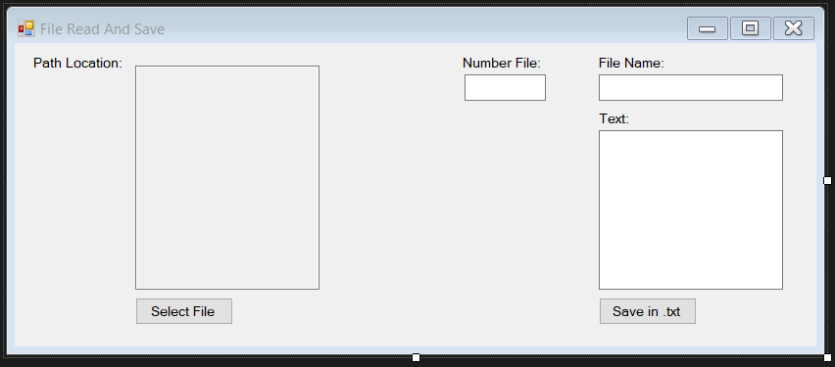

**Exercise 3**

Have an input method (textbox for example) that the user would say how many files he wants to create being able to create a **SPAM Machine**. Remember to do this inside a folder so you can easily delete it after.

**Exercise 4**

Create a **BLOCKER** that its main intention it’s to block all the user’s interactivity or actions in Windows until your secret key is pressed. Example: Blocks PC until I enter “Z”

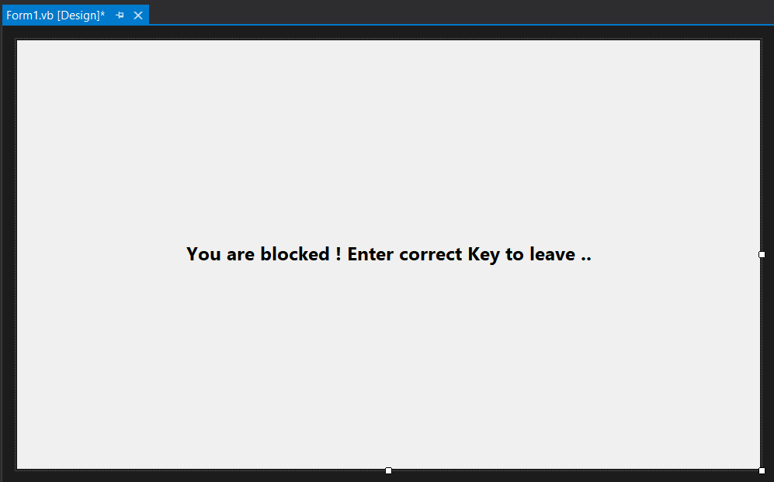

Email your project results in a .Rar or .Zip format to eduplus.luiscunha@gmail.com